Observing the Johnson Noise and Shot Noise

Steven Nguyen

Tony Nguyen

4/11/18

Physics 160

Abstract

Our goal is to obtain the Johnson noise and shot noise in order to verify the value of Boltzmann constant, using Johnson noise, and verifying the fundamental charge, using shot noise. To achieve this, we use a Low Level Electronic and High Level Electronic device to generate noise through varying parameters such as resistor and frequency. We then recorded the data of voltages from the multimeter to derive the voltage of Johnson noise. We obtained our Boltzmann’s constant, 1.372x10^-23 using a constant resistor (10 ohms) and 275 as our temperature in Kelvins. Using a constant changing frequency, 100 KHz-0.3 KHz, and the same T 275 K, we have a Boltzmann’s constant of 1.67x10^-23. Our values for both graphs gave us values close to the accepted Boltzmann’s constant (1.38x10^-23).

Introduction

When generating current, two types of noises occur: Johnson noise and Shot noise. Both of these noises can be recorded and used to extrapolate information on variables affecting our experiment. Johnson noise can be derived through equation 1 if we are given our V meter, Gain 1 and 2. We can then use equation 2 to see how much of an effect Johnson noise has on Boltzmann’s constant.



Equation 1 is used to derive our Johnson noise, Vj squared, through using Vmeter obtained from the voltmeter and 600 and 300 are our Gain 1 and Gain 2. These 2 Gain values differ depending on which slope we are finding. [1]

Equation 2 is used to help solve our Boltzmann’s constant, Kb, with T being constant and delta f or R being constant depending on the graph and slope we are using. Both should give us values close to the accepted Boltzmann’s constant 1.38x10^-23. [1]

Materials and Methods

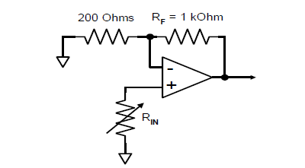First we need to obtain our Johnson noise so we can use to observe our accuracy with Boltzmann’s constant. We can obtain the Johnson noise and Boltzmann’s constant by having equipment to measure and create the noise. The following equipment is a Low Level Electronics and High Level Electronics so we can manipulate parameters to creating out noise. We use an oscilloscope to observe the noise, and a multimeter to measure our voltages being generated from our noise. Once we have our equipment, we can generate the noise which will give us Vsquare. V square is our voltages recorded from the multimeter. This V square is used to derive Vj (our voltage for Johnson) which will then help us find our Boltzmann’s constant depending on which variables we choose to be constant. In this case, we have R and delta frequency as constants for two different graphs, while temperature is always 275 K.

Diagram 1 is the schematics for obtaining our Johnson noise already provided in the LLE. We only have to change our frequencies and resistor to find out Boltzman constant. [1]

Second we measure our shot noise by modifying the LLE adding a light bulb and alternating the white wires. After making these configurations, we took data for our changing frequencies and recorded the V squares. These Vsquares were smaller in comparison to the Johnson noise.

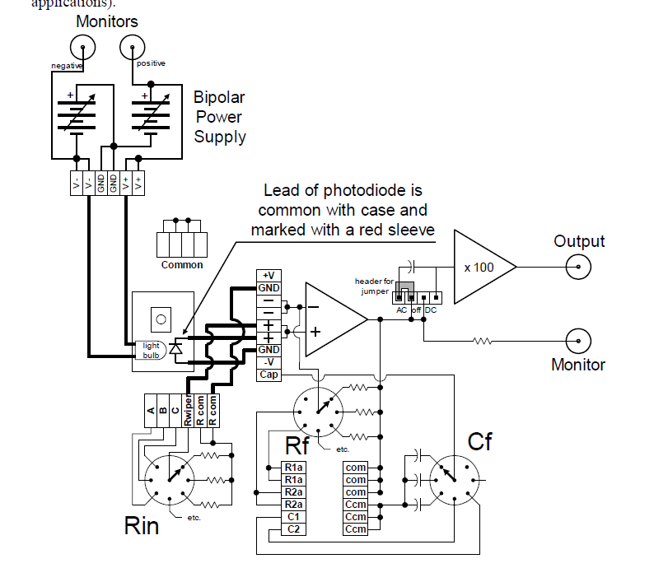

Diagram 2 below shows the configurations needed to make in LLE to obtain data where light bulb is added in with white wires Rwipe and R com moved from its original positions to new positions .[1]

Results

Using the data extrapolated from our voltmeter, we are able to record the values of Vmeter or V squared. These voltages are used to derive our Vj. Note, we have certain parameters changed based off the graph. For example, Graph 1 has a constant resistor while Graph 2 has a constant frequency. However, both graphs do have the same constant temperature. Using the slope of each graph, we are able to isolate equation 2 above for Kb constant alone with the considerations of our constants. Graph 1 has 1.372 x10^-23 while Graph 2 has 1.67x10^-23 as their Boltzmann’s constants.

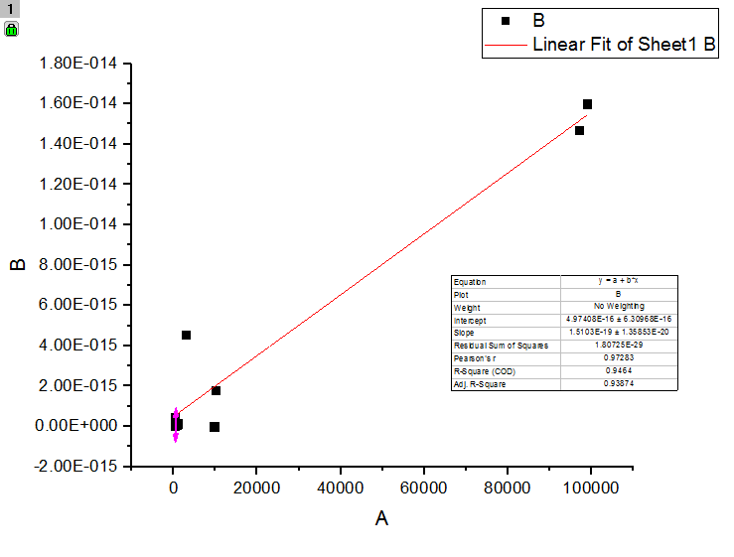

Graph 1 is given above with a constant resistor, 10 Ohms, and it has Gain 1 of 600 and Gain 2 of 400. B axis is our Vj^2 while A is our changing frequency.

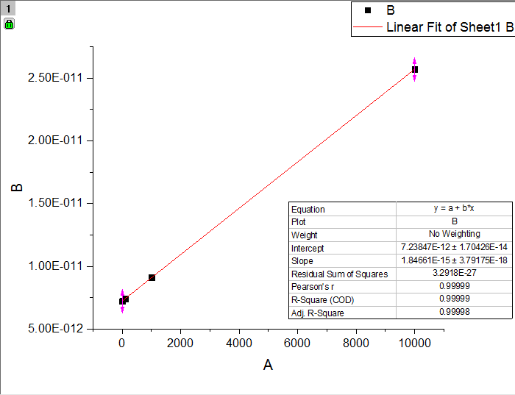

Graph 2 is used to find our second Boltzmann’s constant where our Gain 1 is 600 and Gain 2 is 1500. Our frequency is constant where f2 is 100 kHz and f1 is 0.3 kHz. Our B axis is our Vj^2 while our A axis is our changing frequency.

Discussion

In theory, it shouldn’t matter which graph we looked at since both graphs should give us Boltzmann’s constants that are the same as the accepted value. Based off our first graph, we managed to obtain a Boltzmann’s constant close to the accepted value. (Comparing 1.372 x10^23 from Graph 1 vs 1.38 x10^-23 accepted Boltzmann’s constant) This is surprising since our second graph gave us a value of 1.672 x10^-23, which could be due to mathematical error on either equations. These mathematical errors could be misinterpreting certain variables, mainly our Voltage Johnson, and misinterpreting our Voltage squared. It is possible that outside noise caused the second value to be inaccurate, since the second part of the lab we did discuss more often. To mitigate these errors for future labs, we could be clearer with our data recording and be wary of which equation to use for certain cases. We should do the math ahead of time to keep our data recording neat, and not have any confusion. We can also keep our chatting, just the students who are doing this experiment, to a minimum to keep the noise from interfering with our data.

References

1. Stepp, Stephanie. NMR procedures, UCM “mybox” web access